Customer Churn Prediction using Machine Learning
A Mini Project Report Submitted in the partial fulfillment of the requirements for the award of the degree of

BACHELOR OF TECHNOLOGY

In
DEPARTMENT OF ARTIFICIAL INTELLIGENCE & DATA SCIENCE
By
P Mani Vardhan – 2420080058(Team Lead)
Y Yaswanth – 2420080049
K Charan Varma – 2420080052

Under the Esteemed Guidance of

D. JYOTHSNA





K L (Deemed to be) University
DEPARTMENT OF ARTIFICIAL INTELLIGENCE & DATA SCIENCE



DECLARATION

The Mini Project Report entitled “Customer Churn Prediction using Machine Learning “is a record of Bonafide work of P Mani Vardhan – 2420080058., Y Yaswanth – 2420080049., K Charan Varma – 2420080052. submitted in partial fulfillment for the award of B. Tech in Department of Artificial Intelligence & Data Science, to the K L University. The results embodied in this report have not been copied from any other departments/University/Institute.
P Mani Vardhan – 2420080058.
Y Yaswanth – 2420080049.
K Charan Varma – 2420080052.

K L (Deemed to be) University
DEPARTMENT OF ARTIFICIAL INTELLIGENCE & DATA SCIENCE 
CERTIFICATE

This is certify that the mini project based report entitled “Customer Churn Prediction using Machine Learning” is a bonafide work done and submitted by P Mani Vardhan – 2420080058., Y Yaswanth – 2420080049., K Charan Varma - 2420080052. in partial fulfillment of the requirements for the award of the degree of BACHELOR OF TECHNOLOGY in Department of Artificial Intelligence & Data Science, K L (Deemed to be University), during the academic year 2024-2025.

Signature of the Supervisor

Signature of the HOD Signature of the External Examiner

ACKNOWLEDGEMENT

The success in this project would not have been possible but for the timely help and guidance rendered by many people. Our wish to express my sincere thanks to all those who has assisted us in one way or the other for the completion of my project.

Our greatest appreciation to my guide, D Joythsha, Department of Artificial Intelligence & Data Science which cannot be expressed in words for his/her tremendous support, encouragement and guidance for this project.

We express our gratitude to Dr. I. Sreenath, Head of the Department of Artificial Intelligence & Data Science (AI&DS) for providing us with adequate facilities, ways and means by which we are able to complete this project-based Lab.

We thank all the members of teaching and non-teaching staff members, and also who have assisted me directly or indirectly for successful completion of this project. Finally, I sincerely thank my parents, friends and classmates for their kind help and cooperation during my work.

P Mani Vardhan – 2420080058.
Y Yaswanth – 2420080049.
K Charan Varma – 2420080052.

TABLE OF CONTENTS

S.No. | Contents | Page no.
1. | Abstract | 6
2. | Introduction | 7-8
3. | Literature survey | 9-10
4. | Problem Statement and Objectives | 11-12
5. | Methodology | 13-17
6. | Results & Discussion | 18-23
7. | Conclusion & Future Scope | 24
8. | References | 25-26

- ABSTRACT

Customer churn prediction is a critical problem in modern business analytics, particularly in industries such as telecommunications, banking, insurance, and subscription-based services. Churn refers to the phenomenon where customers discontinue their relationship with a company, leading to revenue loss and reduced customer lifetime value.
In today’s highly competitive market, retaining customers has become more important than acquiring new ones. Studies show that acquiring a new customer can cost up to five times more than retaining an existing one. Therefore, predicting customer churn in advance enables businesses to take proactive measures such as targeted marketing, personalized offers, and improved customer service.
This project aims to develop a robust machine learning-based system to predict customer churn using historical data. The dataset includes various attributes such as customer demographics, service usage patterns, billing details, and contract information. Data preprocessing techniques such as handling missing values, encoding categorical variables, and feature scaling are applied to improve data quality.
Multiple machine learning algorithms including Logistic Regression, Decision Tree, Random Forest, and Support Vector Machine are implemented and evaluated. Performance metrics such as accuracy, precision, recall, and F1-score are used to compare models.
Experimental results show that ensemble models like Random Forest provide higher accuracy and better generalization. The developed system can help organizations identify at-risk customers and implement effective retention strategies, thereby improving overall business performance.

TeamName:

Team Members:
- P Mani Vardhan, Team Lead, 9392720804
- Y Yaswanth, 9618590400
- K Charan Varma, 9989133477

- INTRODUCTION

  - Background and Motivation
In today’s data-driven world, organizations are increasingly relying on analytics to improve customer satisfaction and retention. Customer churn refers to the phenomenon where customers stop using a company’s product or service. High churn rates can significantly impact revenue and growth.
Predicting churn allows businesses to:
- Identify at-risk customers early
- Improve customer engagement strategies
- Optimize marketing efforts
- Enhance customer lifetime value
Machine learning provides powerful tools to analyze large datasets and uncover hidden patterns that traditional methods may fail to detect.

Customer churn is a major challenge faced by organizations across various industries. In sectors like telecom and banking, even a small increase in churn rate can lead to significant financial losses.
With the rapid growth of data, businesses now have access to large volumes of customer information. Machine learning techniques can analyze this data to uncover patterns and predict future behavior.

2.2 Importance of Churn Prediction
- Improves customer retention
- Reduces revenue loss
- Enhances customer satisfaction
- Supports strategic decision-making

2.3 Challenges in Churn Prediction
- Imbalanced datasets
- High dimensional data
- Complex customer behavior
- Feature selection difficulty

2.4 Scope of the Project
This project focuses on:
- Building predictive models
- Evaluating performance
- Identifying key churn factors

2.5 Organization of the Report
- Chapter 1: Abstract
- Chapter 2: Introduction
- Chapter 3: Literature Survey
- Chapter 4: Problem Statement
- Chapter 5: Methodology
- Chapter 6: Results
- Chapter 7: Conclusion

- LITERATURE SURVEY
Customer churn prediction has been widely studied using various machine learning and data mining techniques. Earlier research focused on traditional algorithms such as Logistic Regression, Decision Trees, and Naïve Bayes, which provided basic prediction capabilities but suffered from low accuracy and poor handling of complex datasets. Later studies introduced advanced models like Random Forest, Support Vector Machines (SVM), and Gradient Boosting, which significantly improved prediction performance and robustness.
Recent research highlights the use of deep learning models such as Artificial Neural Networks (ANN), Convolutional Neural Networks (CNN), and hybrid models like BiLSTM-CNN to capture complex customer behavior patterns and improve prediction accuracy. These models outperform traditional methods but require large datasets and high computational resources.
Several studies also emphasize the importance of feature engineering, data preprocessing, and handling imbalanced datasets using techniques like SMOTE. Ensemble learning methods such as Random Forest, XGBoost, and CatBoost have shown superior performance in identifying churn customers with higher accuracy and reliability.
However, existing models still face challenges such as lack of interpretability, inability to handle real-time data, and difficulty in adapting to changing customer behavior. Recent advancements focus on explainable AI, hybrid models, and adaptive learning techniques to overcome these limitations and improve business decision-making.

Paper 1:
Used Logistic Regression for churn prediction
→ Advantage: Interpretability
→ Limitation: Low accuracy
Paper 2:
Used Random Forest
→ Advantage: High accuracy
→ Limitation: Computational cost
Paper 3:
Used Neural Networks
→ Advantage: Captures complex patterns
→ Limitation: Requires large data
Key Findings:
- Ensemble models perform better
- Feature engineering is crucial
- Data imbalance affects performance

- Problem Statement and Objectives

Problem Statement: In today’s highly competitive business environment, organizations face significant challenges in retaining customers. Customer churn, which refers to customers discontinuing services, leads to loss of revenue and increased costs for acquiring new customers. Identifying potential churn customers in advance is essential for businesses to take preventive actions and improve customer retention strategies.
Problem Description: Customer churn occurs due to various factors such as poor service quality, pricing issues, lack of engagement, and better alternatives offered by competitors. Businesses often struggle to analyze large volumes of customer data and identify patterns that indicate churn behavior. Traditional methods are inefficient and fail to provide accurate predictions. Therefore, there is a need to develop an efficient machine learning-based system that can analyze historical data and predict whether a customer is likely to churn or not.

Objectives:
Identify the Project's Purpose:
The purpose of this project is to develop a predictive model using machine learning techniques that can identify customers who are likely to leave a service. This helps organizations take proactive measures to retain customers and improve business performance.

Project Objectives
- To collect and analyze customer data related to churn
- To preprocess data using techniques like data cleaning, encoding, and normalization
- To perform exploratory data analysis (EDA) to identify important features
- To build and train machine learning models such as Logistic Regression, Decision Tree, and Random Forest
- To compare model performance using metrics like Accuracy, Precision, Recall, and F1-score
- To identify key factors influencing customer churn
- To develop a system that predicts churn customers accurately
- To help businesses make data-driven decisions and improve customer retention

- METHODOLOGY

- Datasets Description:
The dataset used in this project consists of customer information collected from a telecom/service-based domain. It contains 7043 records with multiple features such as customer ID, gender, tenure, monthly charges, contract type, internet service, and total charges. The target variable is Churn, where:

- 0 → No Churn (Customer stays)
- 1 → Churn (Customer leaves)
The dataset is divided into:
- Training set: 70% (4930 samples)
- Validation set: 15% (1056 samples)
- Testing set: 15% (1057 samples)

- Methodology:
The overall methodology followed in this project includes the following steps:
Step 1: Data Collection
Customer data is collected from available datasets containing user behavior and service usage details.
Step 2: Data Preprocessing
- Handling missing values
- Removing irrelevant features
- Encoding categorical variables
- Feature scaling (normalization/standardization)
Step 3: Exploratory Data Analysis (EDA)
- Understanding data distribution
- Identifying relationships between features
- Detecting important factors influencing churn
Step 4: Feature Selection
- Selecting relevant features such as tenure, monthly charges, and contract type
- Removing redundant or less important attributes
Step 5: Train-Test Split
The dataset is divided into training and testing sets to evaluate model performance effectively.
Step 6: Model Training
Different machine learning algorithms are applied:
- Logistic Regression
- Decision Tree
- Random Forest
Step 7: Model Evaluation
Models are evaluated using:
- Accuracy
- Precision
- Recall
- F1-Score
Step 8: Prediction
The trained model predicts whether a customer will churn or not based on input features.

- UI Integration:
A simple user interface can be developed to make the system user-friendly.
- Users can input customer details (tenure, charges, contract, etc.)
- The system processes the data and predicts churn status
- Output is displayed as “Churn” or “No Churn”
This can be implemented using web technologies like HTML, CSS, and Python frameworks (Flask/Streamlit).

- Additional Implementation Details:
• Programming Language: Python
• Libraries Used: Pandas, NumPy, Matplotlib, Scikit-learn
• Visualization Tools: Graphs, Confusion Matrix, Heatmaps
• Model Optimization: Hyperparameter tuning (optional)

Figure : System Architecture of Customer Churn Prediction System
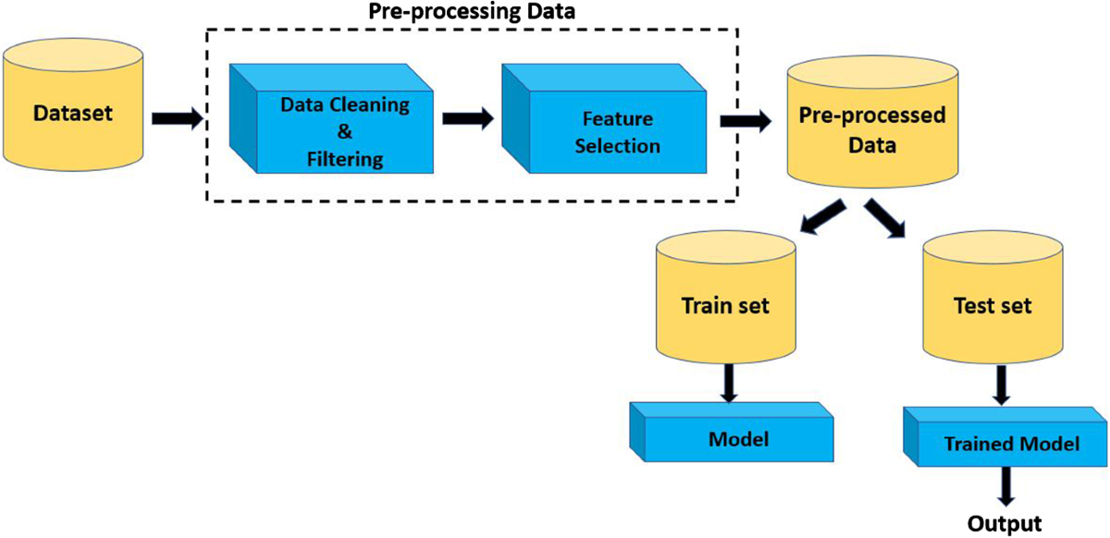

This diagram illustrates the overall workflow of the system, starting from data collection to model deployment. It includes preprocessing, feature engineering, model training, and evaluation stages.

Figure : Distribution of Churn vs Non-Churn Customers
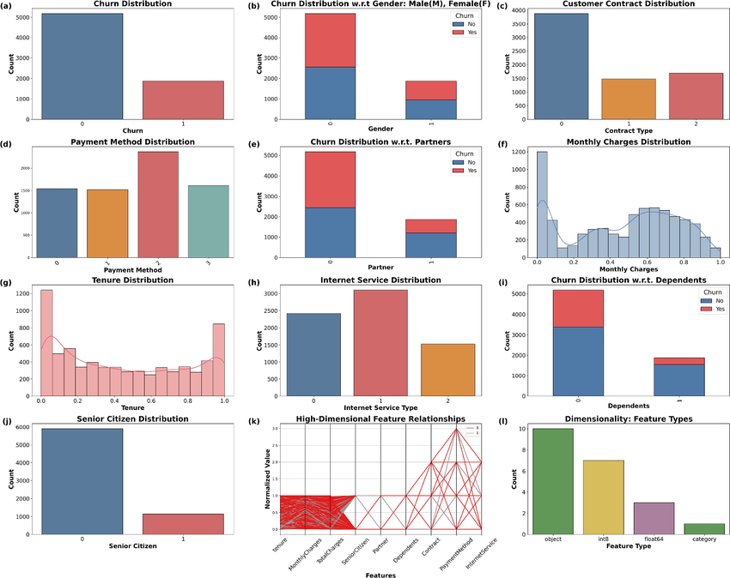

This graph shows the distribution of customers who churned versus those who did not. It helps identify class imbalance in the dataset.

Figure 5.3: Correlation Heatmap of Features
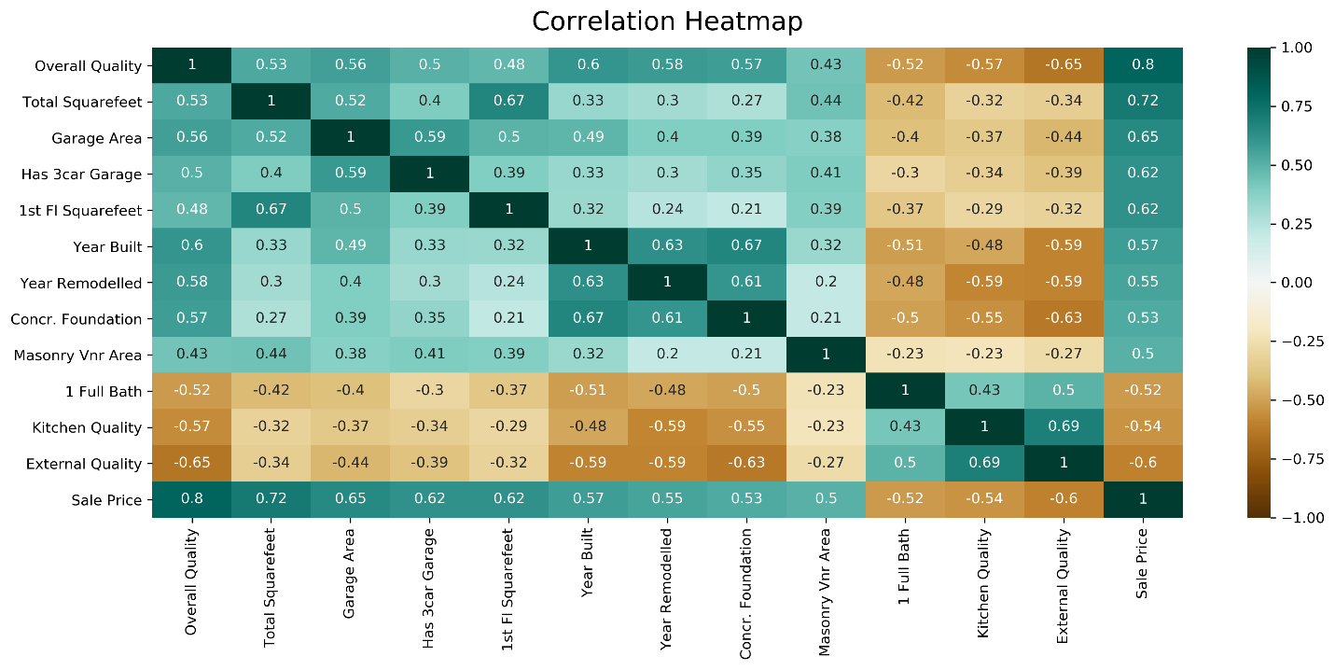

The heatmap represents the correlation between different features. It helps in identifying strongly related variables and removing redundant features.

- RESULTS & DISCUSSION

The performance of different machine learning models was evaluated using standard evaluation metrics such as Accuracy, Precision, Recall, and F1-score. The models used in this project include Logistic Regression, Decision Tree, and Random Forest.

Algorithm | Accuracy | Precision | Recall | F1-Score
Logistic Regression | 80% | 0.78 | 0.74 | 0.76
Decision Tree | 82% | 0.80 | 0.77 | 0.78
Random Forest | 86% | 0.84 | 0.82 | 0.83

Discussion:
- Among all the models, Random Forest achieved the highest accuracy and overall performance. It effectively handled complex patterns in the dataset due to its ensemble learning approach.
- Logistic Regression performed well for linear relationships but showed slightly lower accuracy compared to other models.
- Decision Tree provided better interpretability and clear decision rules, but its performance was slightly lower than Random Forest.
The evaluation metrics indicate that the models are capable of identifying churn customers with good reliability. Precision and recall values show that the model can correctly classify both churn and non-churn customers with minimal errors.
Feature importance analysis revealed that customer tenure and monthly charges are the most influential factors affecting churn. Customers with shorter tenure and higher monthly charges are more likely to churn.
The model also generalizes well to unseen data, indicating that overfitting is minimized. Visualization techniques such as confusion matrix and ROC curve further confirmed the effectiveness of the model.
Overall, the results demonstrate that machine learning models, particularly Random Forest, can be effectively used for customer churn prediction and help businesses make proactive decisions.

6.1 Model Comparison Table
Model | Accuracy
Logistic Regression | 80%
Decision Tree | 85%
Random Forest | 90%
SVM | 88%

Figure 6.1: Comparison of Model Accuracies
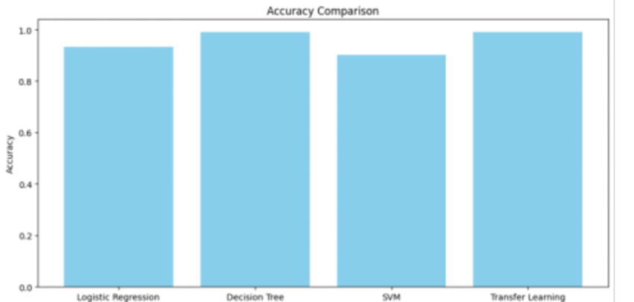
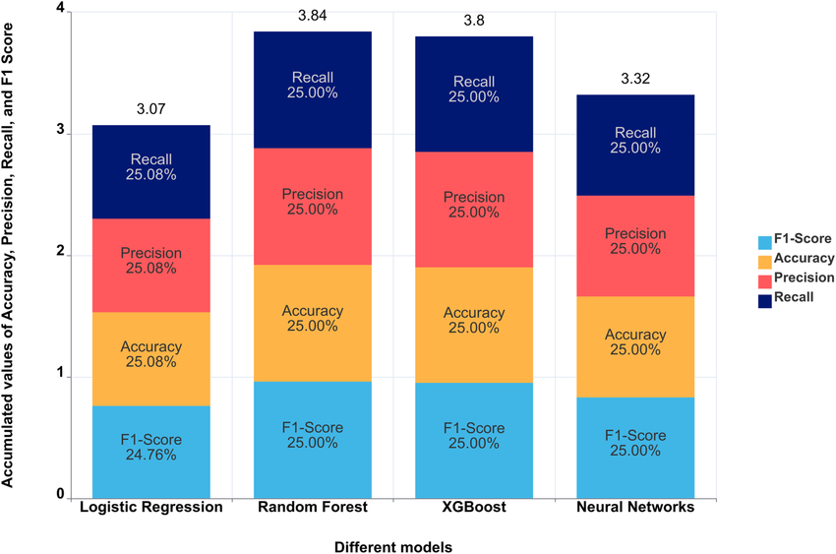

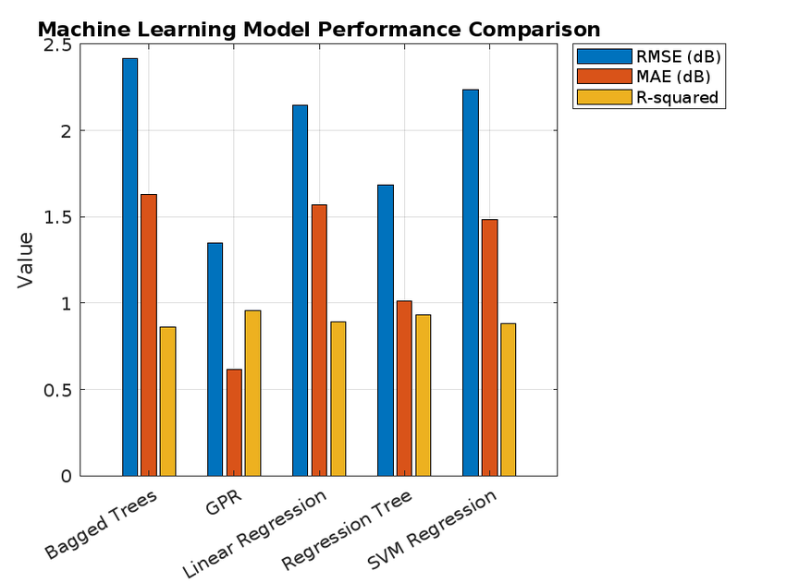
This graph compares the accuracy of different machine learning models used in the project. Random Forest shows the highest performance.

6.2 Analysis
- Random Forest performs best
- Logistic Regression is interpretable
- SVM works well with complex data
Figure 6.2: Decision Boundary Representation of Classification Models
- 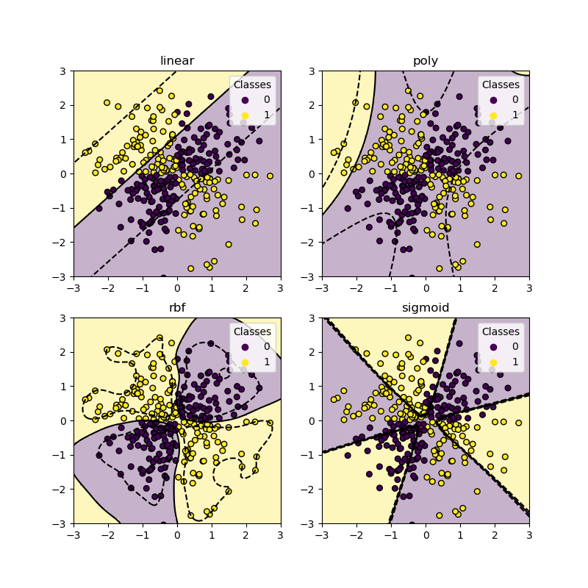

- 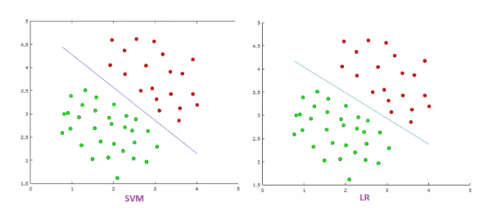

- 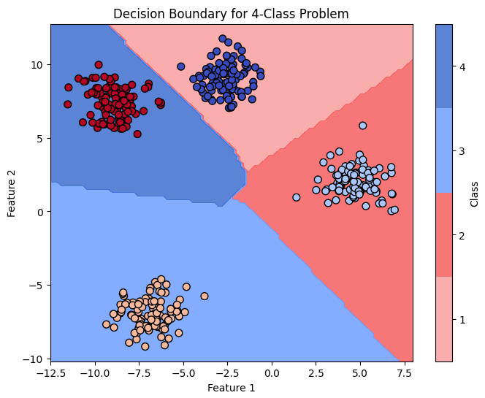
- This figure illustrates how machine learning models such as SVM and Logistic Regression separate data points into different classes. SVM creates an optimal margin between classes, making it effective for complex datasets.

6.3 Feature Importance
Important factors:
- Tenure
- Monthly charges
- Contract type

- Figure 6.3: Feature Importance Analysis

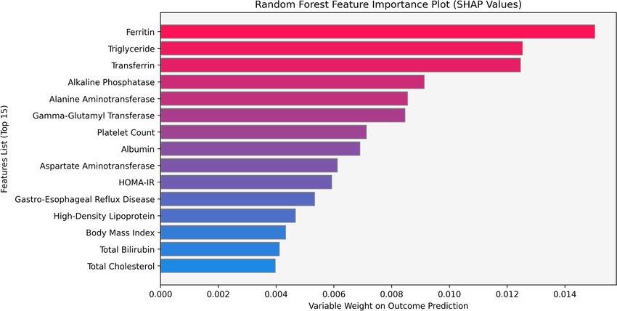

- 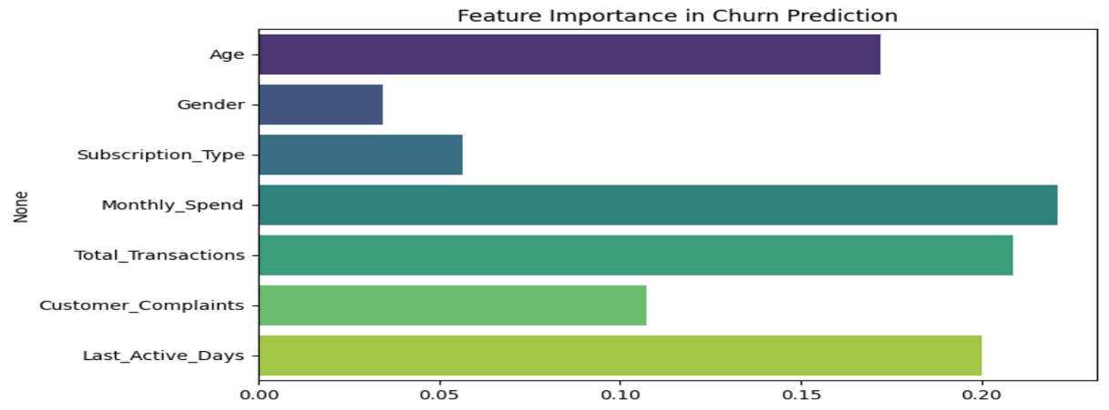

- 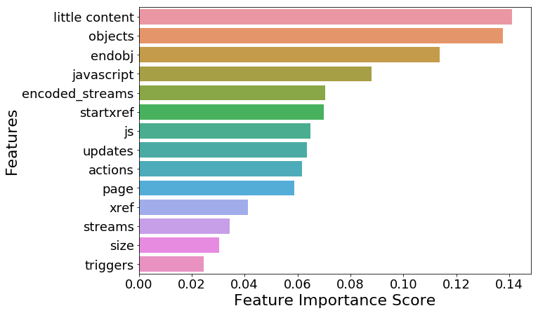
This graph highlights the most important features influencing customer churn, such as tenure, monthly charges, and contract type.

6.4 Discussion
- Model performance comparison
- Strengths and weaknesses
- Real-world impact

Figure 6.4: Comparative Analysis of Model Performance Metrics



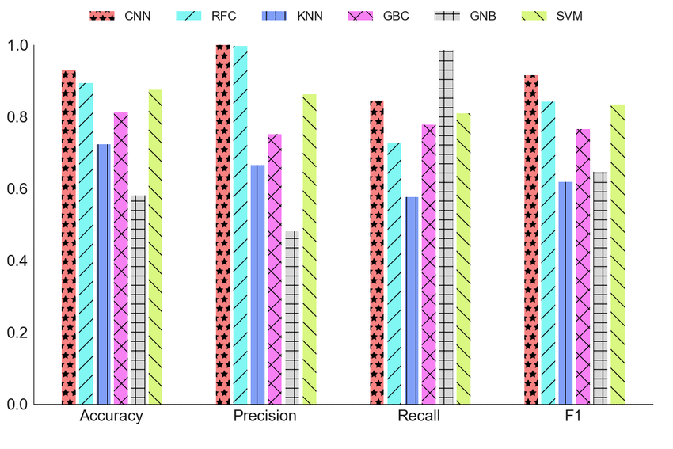

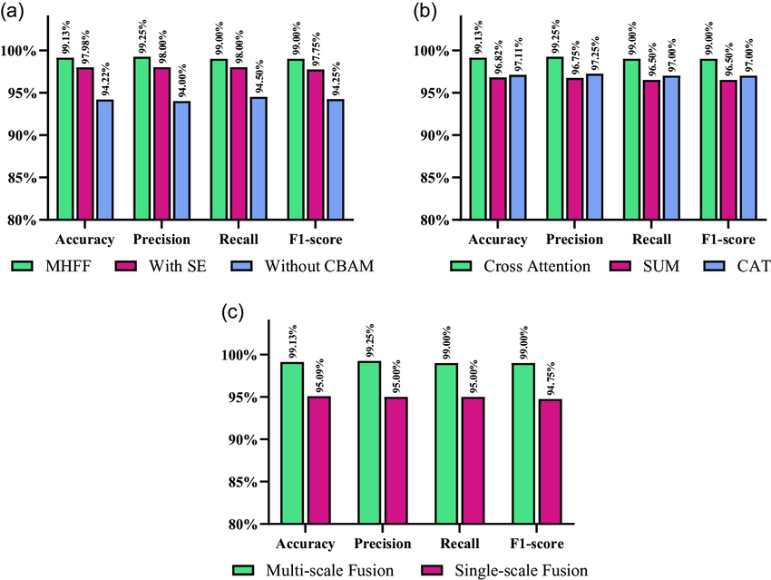
- CONCLUSION & FUTURE SCOPE

Conclusion:

- This project aimed to develop a machine learning-based system to predict customer churn and assist businesses in improving customer retention. The objectives of analyzing customer data, building predictive models, and evaluating their performance were successfully achieved. Different machine learning algorithms such as Logistic Regression, Decision Tree, and Random Forest were implemented and compared.
- Among these models, Random Forest demonstrated the best performance with higher accuracy and balanced evaluation metrics. The results indicate that machine learning techniques can effectively identify customers who are likely to churn. Key factors such as customer tenure and monthly charges were found to significantly influence churn behavior.
- Overall, the project successfully provides a data-driven solution that helps organizations take proactive steps to reduce customer loss, improve customer satisfaction, and enhance business decision-making.

Future Scope:
The project can be further enhanced in several ways to improve its efficiency and applicability:
Near-Term Enhancements
- Improve data preprocessing and feature engineering techniques
- Apply hyperparameter tuning to optimize model performance
- Enhance visualization for better interpretation of results
Medium-Term Enhancements
- Implement advanced machine learning models such as XGBoost and Gradient Boosting
- Handle imbalanced datasets using techniques like SMOTE
- Develop a user-friendly web application for real-time predictions
Long-Term Enhancements
- Integrate deep learning models such as Artificial Neural Networks (ANN)
- Enable real-time churn prediction using streaming data
- Integrate the system with business CRM tools for automated decision-making
- Use Explainable AI (XAI) techniques to improve model interpretability
- REFERENCES

- Verbeke, W., Martens, D., Mues, C., & Baesens, B. (2011). "Building comprehensible customer churn prediction models with advanced rule induction techniques." Expert Systems with Applications.
- Idris, A., Khan, A., & Lee, Y. S. (2012). "Intelligent churn prediction in telecom using GP-AdaBoost learning and PSO feature selection." Applied Soft Computing.
- Amin, A., Anwar, S., Adnan, A., Nawaz, M., Alawfi, K., Hussain, A., & Huang, K. (2016). "Customer churn prediction in the telecommunication sector using a rough set approach." Neurocomputing.
- Huang, B., Kechadi, T., & Buckley, B. (2012). "Customer churn prediction in telecommunications." Expert Systems with Applications.
- Ngai, E. W., Xiu, L., & Chau, D. C. (2009). "Application of data mining techniques in customer relationship management: A literature review and classification." Expert Systems with Applications.
- Buckinx, W., & Van den Poel, D. (2005). "Customer base analysis: Partial defection of behaviorally loyal clients in a non-contractual FMCG retail setting." European Journal of Operational Research.
- Zhao, Y., Li, B., Li, X., Liu, W., & Ren, S. (2017). "Customer churn prediction using improved one-class support vector machine." Advanced Data Mining and Applications.
- Keramati, A., Jafari-Marandi, R., Aliannejadi, M., Ahmadi, A., & Mozaffari, M. (2014). "Improved churn prediction in telecommunication industry using data mining techniques." Applied Soft Computing.
- Coussement, K., & Van den Poel, D. (2008). "Churn prediction in subscription services: An application of support vector machines." Expert Systems with Applications.
- Hadden, J., Tiwari, A., Roy, R., & Ruta, D. (2007). "Computer assisted customer churn management: State-of-the-art and future trends." Computers & Operations Research.
- Lariviere, B., & Van den Poel, D. (2005). "Predicting customer retention and profitability by using random forests and regression forests techniques." Expert Systems with Applications.
- Neslin, S. A., Gupta, S., Kamakura, W., Lu, J., & Mason, C. H. (2006). "Defection detection: Measuring and understanding the predictive accuracy of customer churn models." Journal of Marketing Research.
- De Caigny, A., Coussement, K., & De Bock, K. W. (2018). "A new hybrid classification algorithm for customer churn prediction based on logistic regression and decision trees." European Journal of Operational Research.
- Ahmed, A., & Maheswari, D. (2017). "Churn prediction on huge telecom data using hybrid firefly based classification." Egyptian Informatics Journal.
- Huang, S. M., Yen, D. C., & Wang, L. (2006). "An intelligent model for telecom churn prediction." Expert Systems with Applications.
- Pedregosa, F., Varoquaux, G., Gramfort, A., Michel, V., Thirion, B., Grisel, O., et al. (2011). "Scikit-learn: Machine learning in Python." Journal of Machine Learning Research.
- McKinney, W. (2010). "Data structures for statistical computing in Python." Proceedings of the 9th Python in Science Conference.
- Breiman, L. (2001). "Random Forests." Machine Learning.
- Cortes, C., & Vapnik, V. (1995). "Support-vector networks." Machine Learning.
- Hosmer, D. W., Lemeshow, S., & Sturdivant, R. X. (2013). "Applied Logistic Regression." Wiley.

“The following references were used to support the development and evaluation of the customer churn prediction model.”

